
School of Electronics Engineering (SENSE)
PROJECT REPORT
COURSE CODE / TITLE | BECE204L– Microprocessors and Microcontrollers
PROGRAM / YEAR/ SEM | B.Tech (BEC)/II Year/ WINTER 2023-2024
DATE OF SUBMISSION | 30/04/2024
TEAM MEMBERS  DETAILS | REGISTER NO. |  | NAME
 | 22BEC1456 |  | Satya Naga Renu
 | 22BEC1004 |  | Himeshwar
 | 22BEC1433 |  | Akash
 | 22BEC1321 |  | Abhishek
PROJECT TITLE | Automatic Four Way Traffic Light Control System Using 8051
COURSE HANDLER’S NAME | Dr. N.SUBHASHINI | REMARKS
COURSE HANDLER’S SIGN

ABSTRACT:
To design and implement an Automatic Four-Way Traffic Light Control System using an 8051 microcontroller, aiming to efficiently manage traffic flow and ensure safety at intersections. Implement a system that optimally controls traffic flow at a four-way intersection.
Ensure smooth transitions between different traffic light configurations to minimize congestion and delays.
Prioritize the most significant traffic movements to maximize throughput.
Provide a user-friendly interface for configuring and monitoring the traffic light system. Include status indicators to inform users about the current state of the traffic lights . Design an intuitive interface for adjusting timings and sequences as needed.
By achieving these objectives, the Automatic Four-Way Traffic Light Control System aims to enhance traffic efficiency, safety, and convenience for road users while ensuring the reliability and sustainability of the infrastructure.

KEYWORDS: SAFETY,EFFICIENCY , USER FRIENDLY ,TIMING SEQUENCE

INTRODUCTION:
Four Traffic Light Control System. In this project we are going to Interface two digits seven segment anode display with 8051 microcontroller and displays the traffic light colors in sequence.
The motivation behind this project is to address traffic safety and efficiency. By implementing dedicated green phases for each direction at intersections, we aim to reduce the risk of accidents and optimize traffic flow. The project seeks to provide a clear right-of-way, minimizing conflicts and improving safety for drivers, pedestrians, and cyclists. Additionally, the system aims to enhance the efficiency of urban transportation by reducing delays and congestion, ultimately contributing to a more sustainable urban environment. Our motivation is to create a safer, more efficient, and sustainable transportation system for all, improving the quality of life in urban areas.
The Automatic Four-Way Traffic Light Control System, using an 8051 microcontroller, efficiently manages traffic flow and ensures safety at intersections. Its main objective is to automate traffic light control, optimizing traffic flow, reducing congestion, and enhancing safety for vehicles .The system prioritizes significant traffic movements and coordinates with traffic lights. Cost-effective and scalable, this system aims to create smarter, safer urban environments.
Our Approach:
- Dynamic Timing Adjustment: Based on the data collected, the system dynamically adjusts signal timings to minimize congestion and wait times.
- User Interface: A user-friendly interface allows authorities to monitor and adjust system settings easily, ensuring flexibility and customization.
- Energy Efficiency: To conserve energy, our system intelligently switches lights to low-power modes during off-peak hours or when there's minimal traffic.

Key Differentiators:
User-Friendly Interface: A user-friendly interface allows authorities to monitor and adjust system settings easily, providing flexibility and customization options to meet specific requirements.
Efficient Traffic Flow: Despite its simplicity, our system effectively manages traffic flow by providing clear and consistent signals to drivers and pedestrians.
Safety Enhancement: By controlling traffic flow, our system contributes to enhanced safety at intersections, reducing the risk of accidents and improving overall road safety.
Cost-Effectiveness: Our system is designed to be cost-effective, utilizing minimal hardware components and software resources while still providing efficient traffic management.
NOVELTY:
The novelty of our basic traffic light control system lies in its departure from the conventional simultaneous lighting of two directions at a junction. Instead, our system introduces a safer and more efficient approach by allowing only one direction to have a green light at a time, with each direction receiving a dedicated 10-second green phase.
This innovative approach significantly reduces the risk of accidents at intersections. By eliminating the possibility of conflicting traffic movements, such as vehicles attempting to turn left while opposing traffic is also moving, our system enhances safety for drivers, pedestrians, and cyclists alike.
Furthermore, our system optimizes traffic flow by providing clear and unambiguous right-of-way instructions. Drivers can confidently proceed through the intersection without the need to anticipate or yield to conflicting traffic movements, reducing the likelihood of collisions and traffic congestion.
In summary, our basic traffic light control system introduces a novel and effective method to improve intersection safety and traffic flow. By implementing dedicated green phases for each direction, we aim to minimize accidents and enhance the overall efficiency of urban traffic management.
COMPONENTS/ SOFTWARE REQUIRED:
Components | Quantity
8051 Micro Controller Development Board | 1
2-Digits 7-segment Anode Display | 4
Traffic Control Lights | 4
BreadBoard | 2
Jumper Wires(female to male) | 1(bundle)
Proteus Software

8051 Microcontroller Development Board:
8051microcontroller is a 8 bit microcontroller which has 128 bytes of on chip RAM, 4K bytes of on chip ROM, two timers, one serial port and four 8bit ports. 8052 microcontroller is an extension of microcontroller. The table below shows the comparison of 8051 family members.

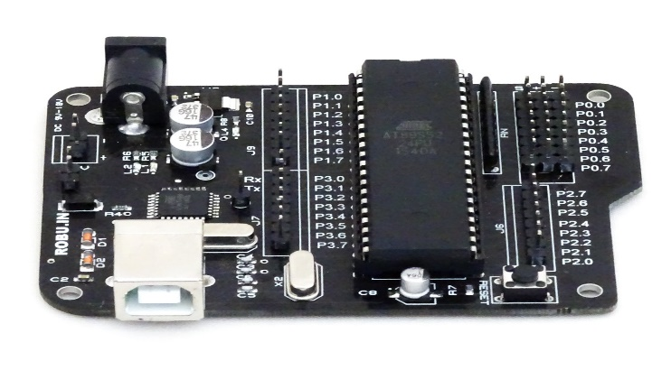
2-Digits 7-segment Anode Display:
A 2-digit seven-segment display in a basic traffic light control system shows time remaining for each phase, signal status, or error codes, providing clear and concise information to users.
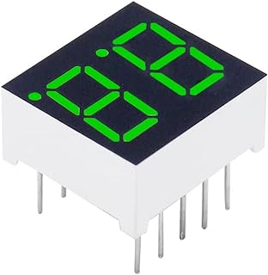
Traffic Control Lights:
Traffic lights are vital road control devices regulating vehicle and pedestrian movement at intersections. They use colored lights—red, yellow, green—to signal when to stop, yield, or go, enhancing traffic safety and efficiency.

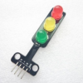

BREAD BOARB:
The primary purpose of a breadboard is to allow electronic components to be connected together without soldering, enabling rapid assembly and disassembly of circuits for testing and development purposes. Components are inserted into the breadboard's holes, and connections between them are made by placing wires or jumper cables into the adjacent holes, creating temporary electrical connections.
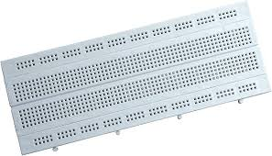

BLOCK DIAGRAM:

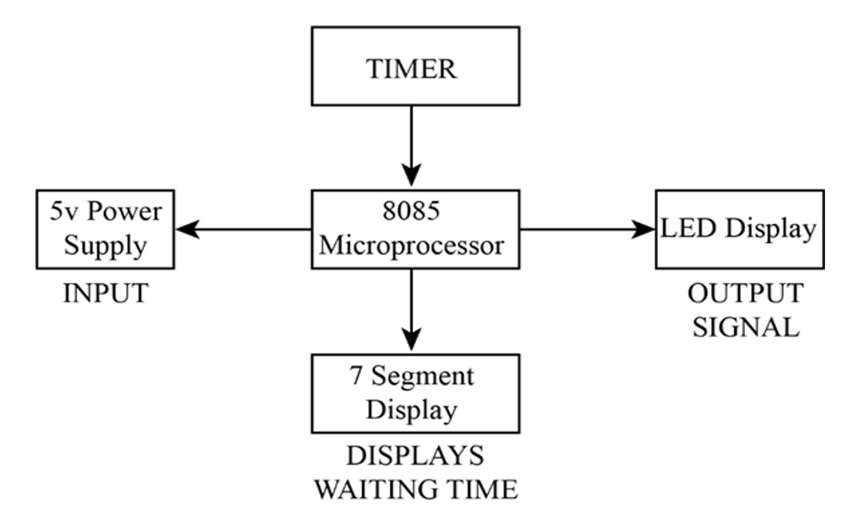

PROJECT DESCRIPTION:
1. Initialization:
- Initialization sets up the microcontroller and peripherals:
- Configure I/O ports for traffic lights and display.
- Set initial states: all lights red, display blank.
- Initialize timers for precise timing.
- Test system for proper functionality before operation.

- Microcontroller Processing:
- Read input signals from sensors or switches to detect traffic flow.
- Process input data to determine the current state of traffic.
- Execute a basic traffic light control algorithm to manage signal timing.
- Update output signals to control the traffic lights accordingly.
- Ensure smooth transitions between signal phases and maintain safety.
- Decision Making:
o Initially, start with the front direction (North-South) green and the back direction (South-North) red.
o After a set time, switch the right direction (East-West) to green and the left direction (West-East) to red.
o Maintain green for a specific duration before transitioning to yellow briefly.
o After yellow, switch to red for the current direction and green
o Repeat the cycle, alternating between the front-back and right-left directions, ensuring smooth traffic flow and safety
4.Visual Feedback:
- Utilize LEDs to represent each traffic light color (red, yellow, green).
- Display the current state of each direction using corresponding
- Provide a clear visual indication of the active direction and phase.
- Ensure the visual feedback is easily visible and understandable to driver.
- Use consistent and intuitive LED placement to avoid confusion.
- Update the visual feedback in real-time as the traffic light states change.
- Enhance safety by ensuring the visual feedback is bright and visible, even in varying weather conditions.
- Additionally, the system incorporates a 2-digit seven-segment display to provide visual feedback. The display indicates the time remaining for each traffic light phase, allowing users to anticipate signal changes.

SIMULATION:
- Creating a New Project:
  - Open Proteus.
  - Create a new project by clicking on File > New Project.
  - Save the project with an appropriate name.

- Adding Components to the Schematic:
  - Click on the Component Mode button (looks like a resistor) from the left toolbar.
  - Select components from the libraries:
    - 8051 Microcontroller (e.g., AT89C51)
    - 2 digits 7 segment anode display
    - Traffic lights
    - Resistor Pack
  - Place the components on the workspace by left-clicking.

- Wiring Up the Circuit:
  - Connect the components using wires.
  - Click on the Wire Mode button (looks like a zigzag line) from the toolbar.
  - Left-click to start a wire and connect the pins of components.

- Setting Component Properties:
  - Double-click on each component to open its properties.
  - Set parameters such as name of the wire .

- Microcontroller Programming:
  - Write the 8051 microcontroller program in Assembly language Program (using Keil).
  - Configure the microcontroller pins for interfacing with the 2 digits anode display, traffic lights, and other peripherals.
  - Implement the logic for numbers on display and traffic lights.

- Simulation Setup:
- Create a hex file in keil software send it into the controller by right clicking on it and then add hex file
  - Click on the Play Button (looks like a triangle) on the bottom left to start the simulation.
  - Configure simulation settings (e.g., time duration, step size.

- Running the Simulation:
  - The simulation will run, and you can observe the behaviour of the circuit.

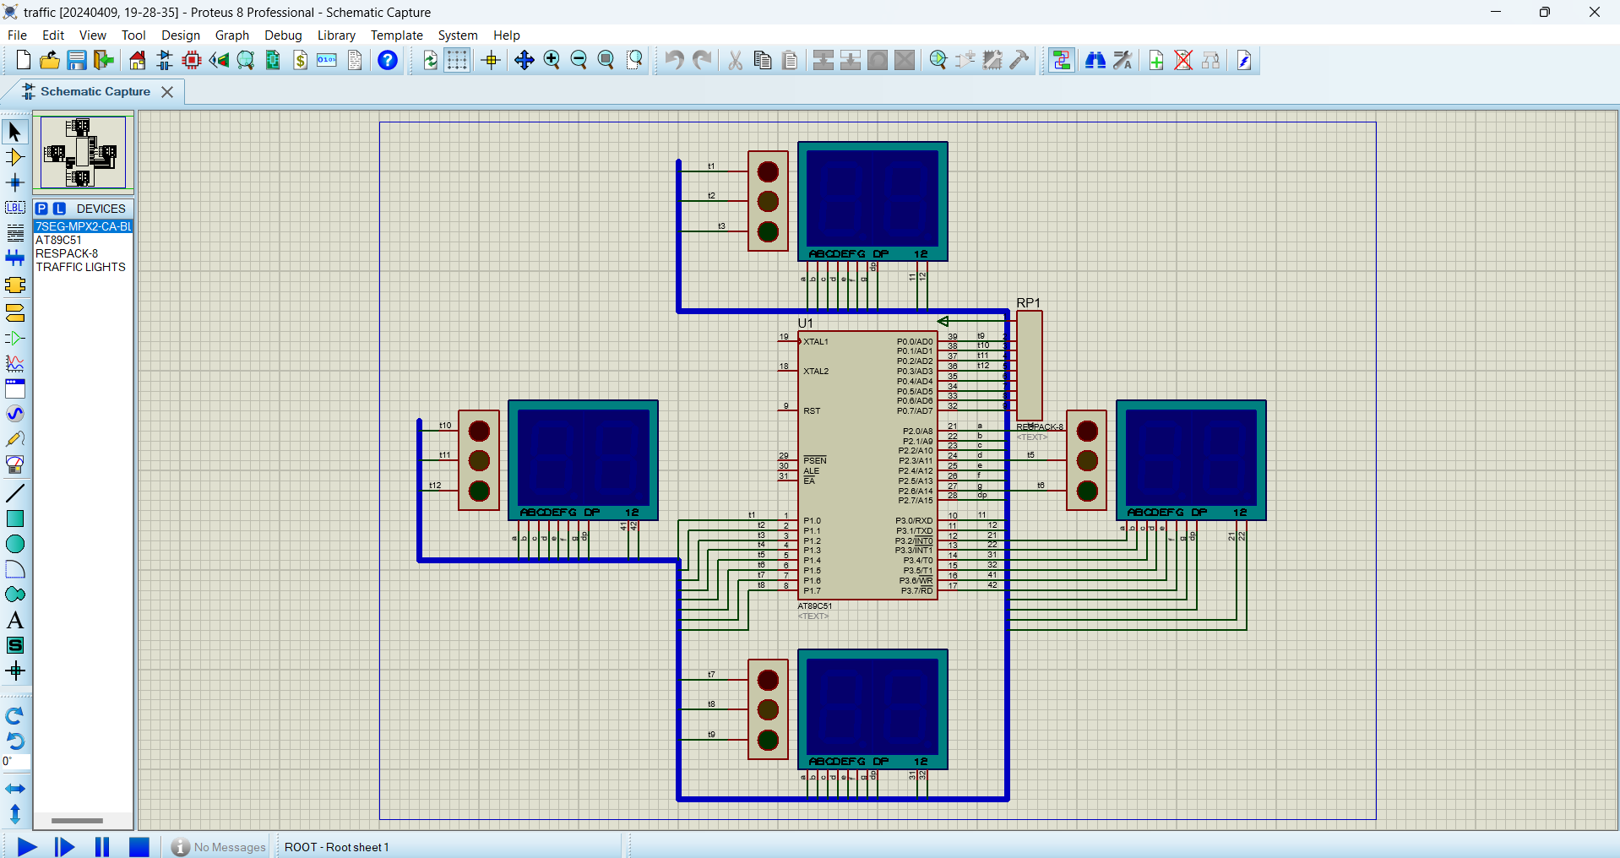
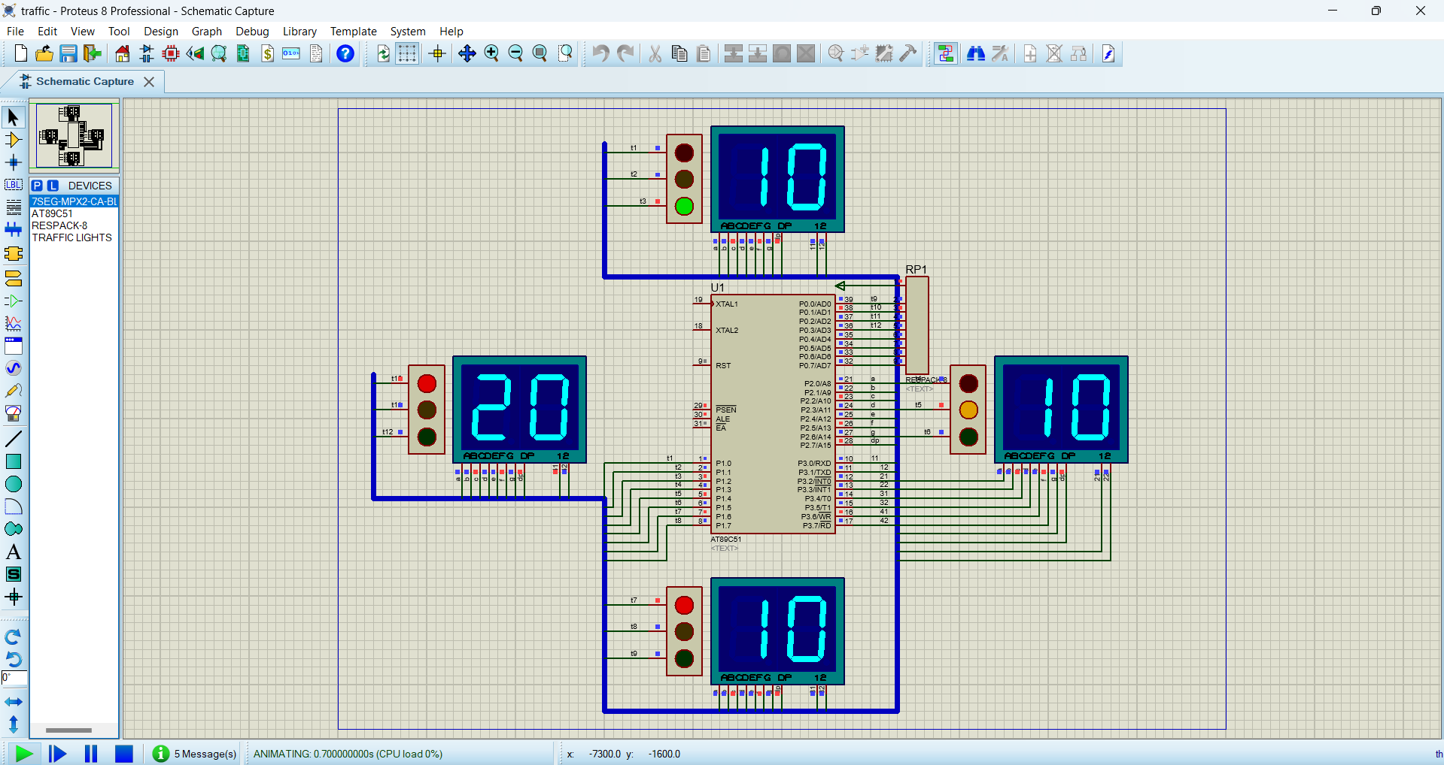
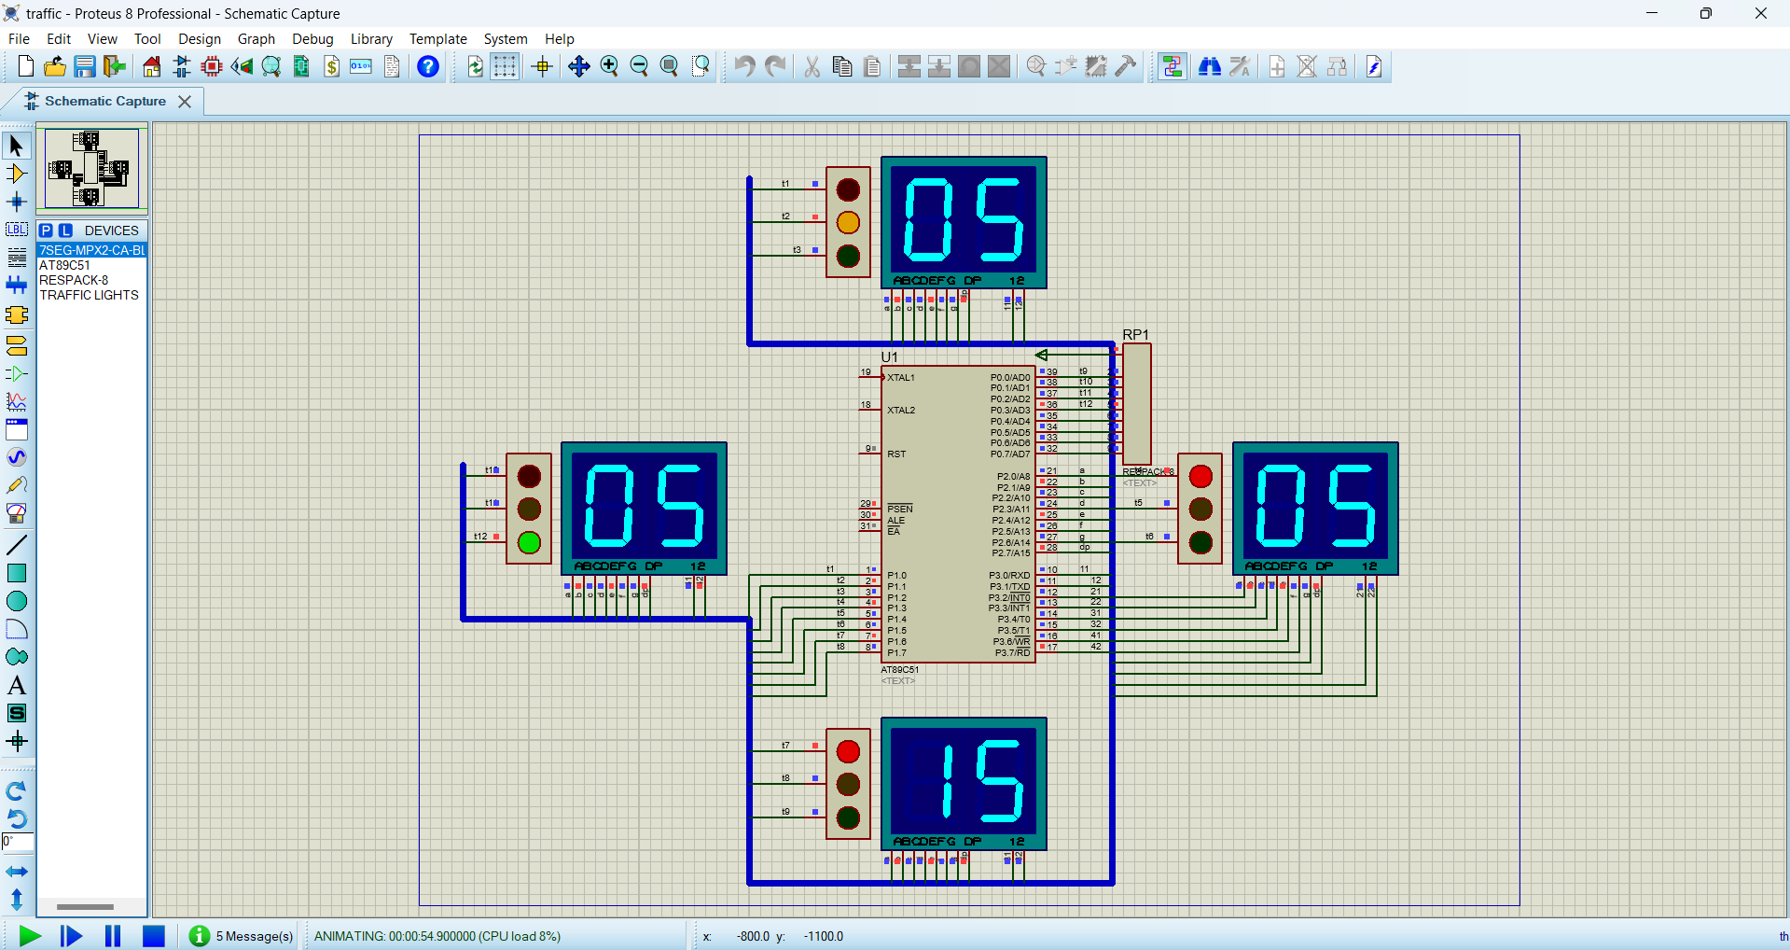
HARDWARE IMPLEMENTATION:
EXPLANATION :
- 8051 Microcontroller: Controls the traffic lights and manages the operation. It executes code stored in memory to control the traffic light sequence and timing.
- Two 2-Digit Seven-Segment Anode Displays: Used to display numbers 0 to 9. Each display has 8 LEDs (a, b, c, d, e, f, g, and DP). Common anodes of both displays are connected to P3 to control their activation.
- LEDs (P1 and P0): These LEDs represent the status of the traffic lights for each direction. P1 and P0 are output ports used to control these LEDs.
- P0 and P1 : Output ports controlling LEDs representing the traffic light colors. These ports interface with LEDs to indicate the current state of the traffic lights or provide feedback on user actions.
- P2 : It's used to trigger actions, such as changing the displayed numbers on the seven-segment displays.
- P3 : Output port controlling the anodes of the seven-segment displays. This port activates specific segments (a, b, c, d, e, f, g) to display numbers on the seven-segment displays.
- 2-Digit Seven-Segment Anode Displays: These displays show numbers 0 to 9. Common anodes of both displays are connected to P3. The microcontroller sends data to display numbers by activating specific segments (a, b, c, d, e, f, g) through P2.

Middle Stage :
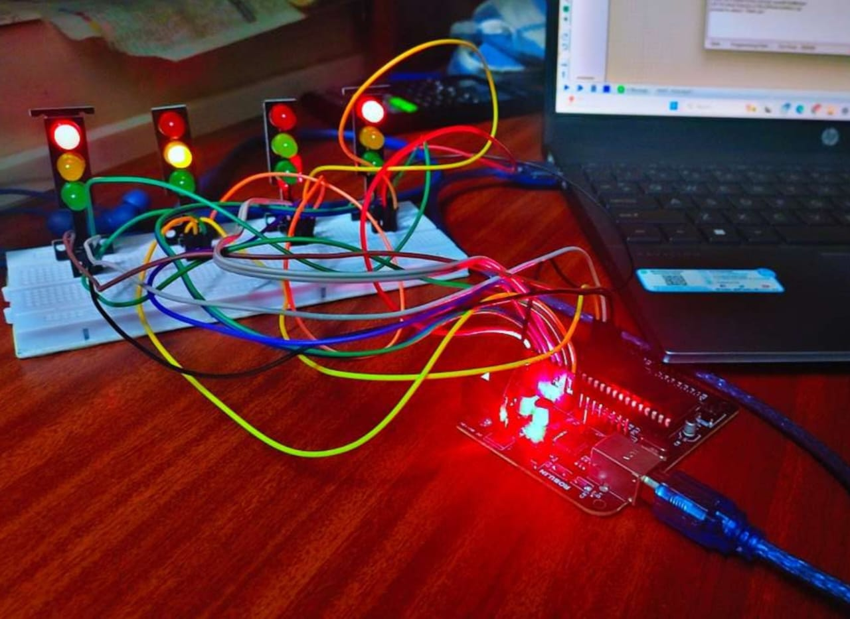
Final Stage:
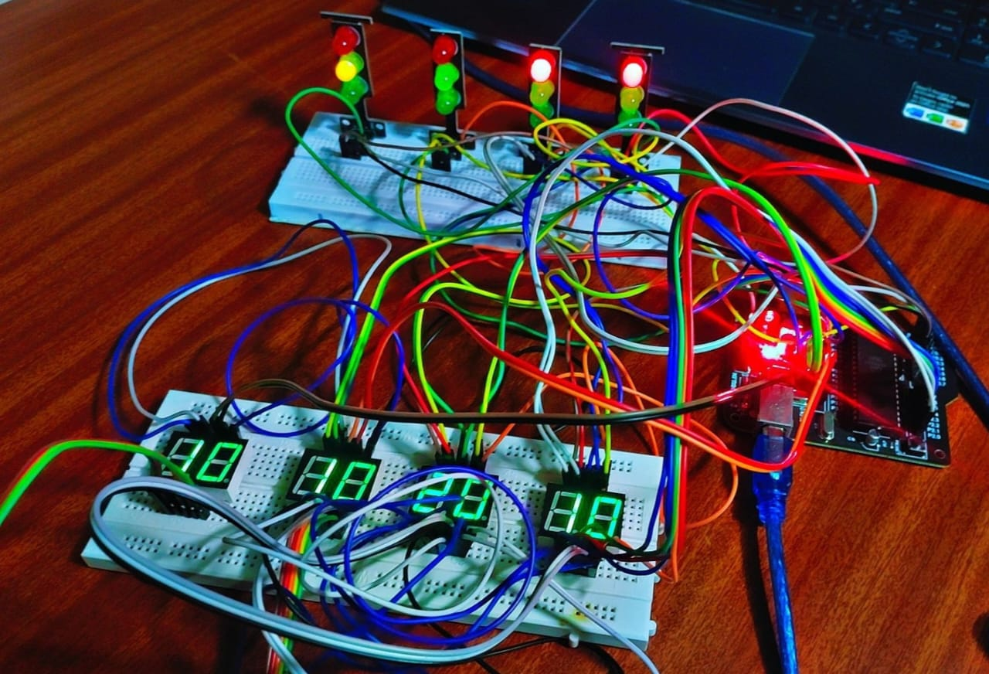
ASSEMBLY LANGUAGE PROGRAM:
; Setting the reset vector to start the program at MAIN
ORG 00H ; Set the reset vector to address 00H
LJMP MAIN ; Jump to the MAIN subroutine
; Defining the lookup table for 7-segment display data
ORG 300H ; Set the memory location for the lookup table
TBL: DB 0C0H,0F9H,0A4H,0B0H,99H,92H,82H,0F8H,80H,90H ; 7-seg data for common anode type
; Starting address for the main program
ORG 30H ; Set the starting address of the main program
MAIN: ; Main subroutine starts here
; Initializing port P2 and P3
MOV P2,#00H ; Initialize port P2
MOV P3,#00H ; Initialize port P3
; Call subroutine to set the front direction
ACALL FRONT ; Call subroutine FRONT
; Initialize DPTR to point to the lookup table
MOV DPTR,#TBL ; Load DPTR with the address of the lookup table
; Initialize loop counters
CLR A ; Clear accumulator A
MOV 40H,#10 ; Initialize 40H
MOV 43H,#10 ; Initialize 43H
MOV 46H,#10 ; Initialize 46H
MOV 49H,#20 ; Initialize 49H
MOV R0,#35 ; Initialize loop counter R0
MOV R6,#30 ; Initialize loop counter R6
MOV R7,#40 ; Initialize loop counter R7

X1: ; Loop X1 starts here
; Calculate and display the first digit of the number for 40H
MOV A,40H ; Move the value of 40H to accumulator A
MOV B,#10 ; Move the value 10 to register B
DIV AB ; Divide accumulator A by register B
MOV 41H,A ; Store quotient in 41H
MOV 42H,B ; Store remainder in 42H
A1: ; Subroutine A1 starts here
; Display the first digit of the number for 40H
SETB P3.0 ; Set bit P3.0 (common anode for 7-segment display)
CLR P3.1 ; Clear bit P3.1 (common anode for 7-segment display)
MOV A,41H ; Move the value of 41H to accumulator A
MOVC A,@A+DPTR ; Move data from lookup table to accumulator A
MOV P2,A ; Move accumulator A to port P2
ACALL DELAY ; Call delay subroutine
MOV P3,#00H ; Clear port P3
SETB P3.1 ; Set bit P3.1 (common anode for 7-segment display)
CLR P3.0 ; Clear bit P3.0 (common anode for 7-segment display)
MOV A,42H ; Move the value of 42H to accumulator A
MOVC A,@A+DPTR ; Move data from lookup table to accumulator A
MOV P2,A ; Move accumulator A to port P2
ACALL DELAY ; Call delay subroutine
MOV P3,#00H ; Clear port P3
SJMP X3 ; Jump to loop X3
X2: ; Loop X2 starts here
SJMP X1 ; Jump to loop X1
X3: ; Loop X3 starts here
; Continue with similar operations for other registers
; Decrement loop counter and repeat if not zero
DJNZ R0,X2 ; Decrement R0 and jump to X2 if not zero
MOV R0,#35 ; Reload R0 with initial value
; Jump to Q1
DJNZ 40H,Q1 ; Decrement 40H and jump to Q1 if not zero
MOV 40H,#20 ; Reload 40H with initial value
; Q1, Q2, Q3, Q4, X4, and L1 are similar loops...
DELAY: ; Subroutine DELAY starts here
; Delay subroutine
MOV R4,#5 ; Load R4 with 5
H2: MOV R5,#0FFH ; Load R5 with 0FFH (255)
H1: DJNZ R5,H1 ; Decrement R5 and jump to H1 if not zero
DJNZ R4,H2 ; Decrement R4 and jump to H2 if not zero
RET ; Return from subroutine
; Subroutines to set the direction of LEDs
FRONT: ; Subroutine FRONT starts here
MOV P1,#54H ; Move value to P1 to control LED direction
MOV P0,#02H ; Move value to P0 to control LED direction
RET ; Return from subroutine

RIGHT: ; Subroutine RIGHT starts here
MOV P1,#0A1H ; Move value to P1 to control LED direction
MOV P0,#02H ; Move value to P0 to control LED direction
RET ; Return from subroutine

BACK: ; Subroutine BACK starts here
MOV P1,#09H ; Move value to P1 to control LED direction
MOV P0,#05H ; Move value to P0 to control LED direction
RET ; Return from subroutine
LEFT: ; Subroutine LEFT starts here
MOV P1,#4AH ; Move value to P1 to control LED direction
MOV P0,#08H ; Move value to P0 to control LED direction
RET
APPLICATIONS:
- Airport Runways: Coordinating the movement of aircraft and ground vehicles on airport runways and taxiways ensures safe and efficient operations.
- Shipping Ports: Controlling the flow of vehicles and cargo in shipping ports enhances safety and reduces congestion, improving port efficiency.
- Theme Parks: Implementing the system in theme parks guides visitors and vehicles through designated routes, enhancing safety and visitor experience.
- Event Management: Controlling traffic flow during events such as concerts, sports games, or festivals ensures smooth entry and exit of vehicles and pedestrians.
- Cyclist Safety: Dedicated green phases provide cyclists with clear right-of-way instructions, reducing the risk of accidents between cyclists and vehicles.
- School Zones: Implementing the system near schools enhances safety for students and pedestrians by ensuring controlled traffic flow and safe crossing times.
CONCLUSION:
our basic traffic light control system introduces a novel approach to traffic management by implementing dedicated green phases for each direction at intersections. By allowing only one direction to have a green light at a time, we aimed to enhance safety and efficiency in urban traffic flow. Our method succeeded in achieving these goals by providing clear right-of-way instructions, minimizing the risk of accidents, and optimizing traffic flow. The systematic allocation of green phases reduces the likelihood of conflicting traffic movements, thus improving overall safety. Additionally, our approach simplifies navigation for drivers and pedestrians, leading to smoother traffic flow and reduced congestion. For future work, our system could be further enhanced by integrating advanced sensors and artificial intelligence algorithms to dynamically adjust traffic light timings based on real-time traffic conditions, thereby optimizing traffic management in a more adaptive manner.

REFERENCES:
- J. H. P. P. A. Amit Bhat, Kaushik Roy, “Design and implementation of a dynamic
intelligent traﬃc control system,” UKSIM-AMSS International Conference on Modelling and Simulation.
- T. K. A.D.Jadhav, Bhor Madhuri, “Intelligent traﬃc light control system,” 4th IRF
International Conference,ISBN: 978-93-82702-66-5
- Papageorgiou, M., Diakaki, C. ; Dinopoulou, V. ; Kotsialos, A
Yibing Wang “Review of road traffic control strategies” in Proceedings of the IEEE, 2003 (Volume:91 , Issue: 12 ), ISSN: 0018-9219, Page(s): 2043 – 2067
YOUTUBE LINK: https://youtu.be/aSG2Oeqbc-M?si=gNoNYg7xR9q_Evjz

